

Title: Artificial Intelligence | Code: CS-351 | Total Marks: 20
Instructor: Dr. Khurram Khan Jadoon | Assignment No: 01 | Deadline: 02/10/2025

Instructions:
Collaboration with classmates is encouraged, but all homework must be completed individually. Copying will not be tolerated. A viva will be conducted at the end of the semester for each homework assignment, so it is important to perform the tasks on your own rather than duplicating someone else's work. Cases of plagiarism will be handled with strict consequences.

Q No 01

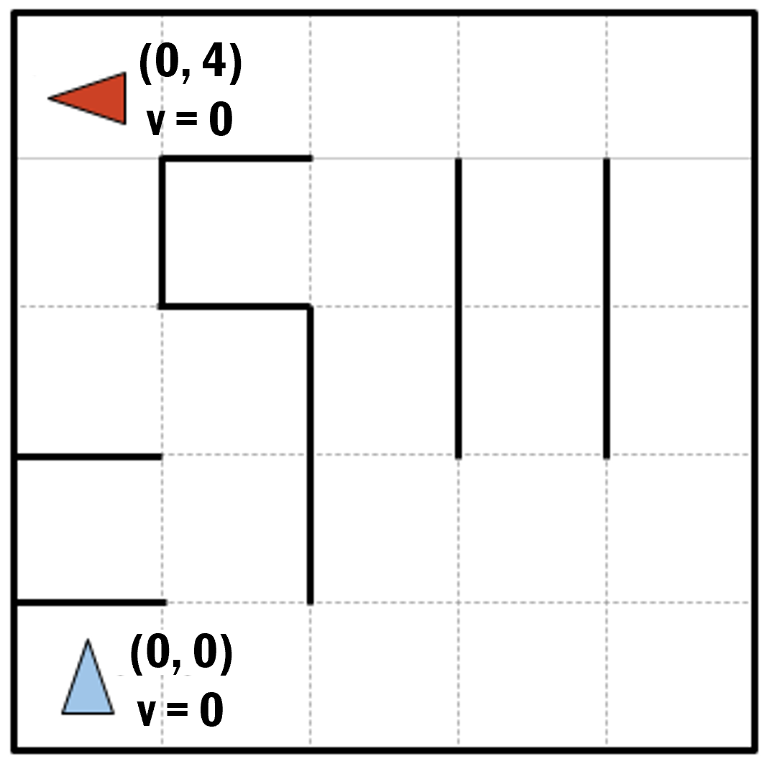

Imagine a car-like agent wishes to exit a maze like the one shown above. The agent is directional and at all times faces some direction d (N, S, E, W ). With a single action, the agent can either move forward at an adjustable velocity v or turn. The turning actions are left and right, which change the agent’s direction by 90 degrees. Turning is only permitted when the velocity is zero (and leaves it at zero). The moving actions are fast, maintain and slow. Fast increments the velocity by 1 and slow decrements the velocity by 1; in both cases the agent then moves a number of squares equal to its NEW adjusted velocity. Maintaining velocity allows the agent to go just as many squares as last time. Any action that would result in a collision with a wall crashes the agent and is illegal. Any action that would reduce v below 0 or above a maximum speed Vmax is also illegal. The agent’s goal is to find a plan which parks it (stationary) on the exit square using as few actions (time steps) as possible.
∈
- Suppose the agent wants to take the leftmost path from the start (0,0) facing north to the goal (0,4) facing west. Write down the sequence of actions for it to take.
- If the grid is M by N, what is the size of the state space? You should assume that all configurations are reachable from the start state.
- What is the maximum branching factor of this problem? Draw an example state (x, y, orientation, velocity, grid/walls) that has this branching factor, and list the set of available actions.
- What is the minimum branching factor? Draw an example state (x, y, orientation, velocity, grid/walls) that has this branching factor, and list the set of available actions.
Q No 02
On the moon Io, one of Jupiter's moons, there are several volcanic rings scattered across the landscape. Scientists are studying these rings to understand the geological history of Io. Each ring is composed of colorful volcanic ash and varies in size.
Problem:
You are in charge of collecting samples from each ring. However, due to the fragile nature of the rings, you can only move one ring at a time and never place a larger ring on top of a smaller ring. You start at a designated landing site with all rings stacked in size order, largest on the bottom. Your goal is to move all rings to a designated research station, again maintaining the size order.

Questions:
- State Representation: Describe how you would represent the state of the system at any given moment.
- State Space Size: What is the size of the state space for this problem (considering any number of rings)?
- Start State: How would you represent the initial state when all rings are stacked at the landing site?
- Legal Actions: Given a state, what are the possible actions you can take (moving rings)? How would you represent these actions?
- Goal Test: How would you determine if a state represents the goal state where all rings are at the research station in the correct order?

Q No 03 (Programming)
Introduction:
In this programming assignment, you will implement Breadth-First Search (BFS) and Depth-First Search (DFS) algorithms to analyze the game state space of Tic-Tac-Toe. The goal is to explore different game states, identify winning positions, and determine optimal strategies using both search algorithms.
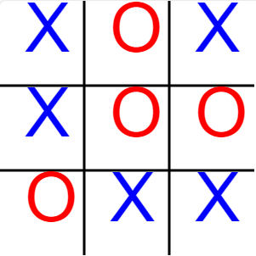
Problem Description:
You are required to implement BFS and DFS and iterative deepening algorithms to analyze the game tree of Tic-Tac-Toe. The Tic-Tac-Toe board is represented as a 3x3 grid where players take turns placing their marks (X or O) until one player achieves a winning configuration or the board is filled without a winner.
Programming Tasks:
- Implement a function to generate all possible next moves from a given Tic-Tac-Toe board state.
- Design functions to implement BFS and DFS algorithms to traverse through the game tree, exploring different game states.
- Design functions to check for winning positions and determine the outcome of the game.
- Analyze the game tree to identify optimal strategies for both players (X and O) .
- Test your implementations with various initial board configurations, including empty boards, partially filled boards, and winning positions.
- Compare the performance of all three in terms of the number of game states explored, time complexity, and efficiency in finding winning positions.

Programming Guidelines:
Represent the Tic-Tac-Toe board as a 2D array or any suitable data structure.
Implement BFS and DFS algorithms using appropriate data structures (e.g., queue for BFS, stack for DFS).
Ensure that your implementations handle edge cases such as invalid board configurations and proper termination conditions.
Write clean and well-commented code to enhance readability and maintainability.

